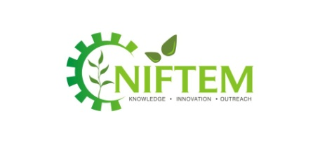
1. Company Information:
CORPORATE RESPONSE SHEET – INTERNSHIP
B.Tech (2015-19), M.Tech (2017-19) & MBA (2017-2019)
Name of the Organization
Contact Person & Designation
E-Mail ID: |  | Contact Number:

2. Internship Details:

Course | Project Details |  | No. of Vacancies
 | Project Area | Project Title
B.Tech - Food Technology and Management
M.Tech
Food Process Engineering and Management
Food Plant Operations Management
Food Safety and Quality Management
Food Supply Chain Management
Food Technology and Management
MBA
(Duration: Mid-week of June 2018- mid week of August 2018)

3. Category of Recruiter / Company ( all the relevant):

Past Recruiter |  | First Time Recruiter |  | Bulk Recruiter |  | General / Start up

4. Details of Visit (Internship Season – January 2018 Onwards):

Date and Time of Visit
No. of Persons Visiting |  | Name and Designation of Visiting Delegates

5. Internship Details:

Internship Dates (B.Tech/ M.Tech)
Internship Dates (MBA)
Stipend (Yes / No) |  | T.A & D.A(if any)
Accommodation (Yes / No) |  | Any other prerequisite(if any)

*Attach a separate sheet if required Signature:
Name:
Designation:
Seal of Organization:
Kindly mail/fax this sheet to:
Sr. Manager, Corporate Resource Division
National Institute of Food Technology Entrepreneurship and Management (NIFTEM)
Plot No. 97, Sector – 56, HSIIDC, Industrial Estate, Kundli, District – Sonepat, Haryana – 131028
Phone: 130-2281032 (1031/1033), Mob: 8607559966, E-Mail: niftem.crd@gmail.com, crd@niftem.ac.in
Skype ID: crd.niftem, Website: www.niftem.ac.in

