Village Adoption Programme

(NIFTEM's Unique Outreach Initiative)

- Food Processing promotional Initiatives
About 500 programmes including Trainings and Expert Lectures, Awareness Camps organized on food processing and value addition, postharvest management, product development, entrepreneurship development etc
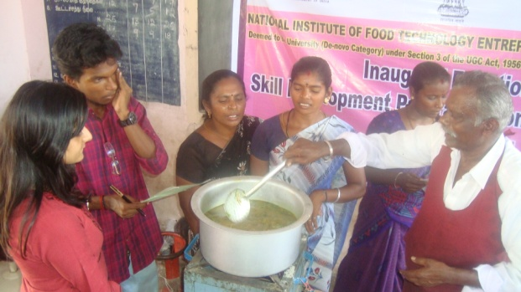 | 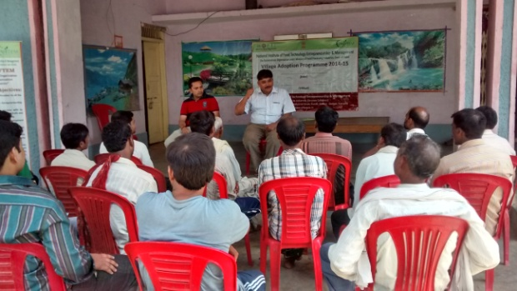
Demonstration on preparation of Mushroom Juice in a Kalupatti village, Dindigul, Tamilnadu | Lecture on Food Processing opportunities in Seoni, Madhya Pradesh
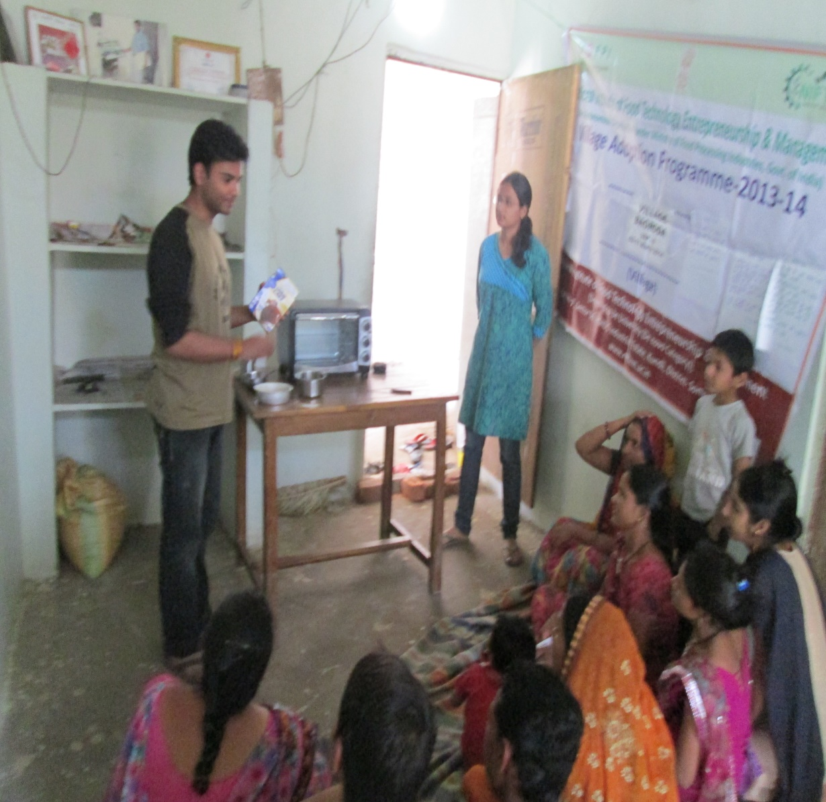 | 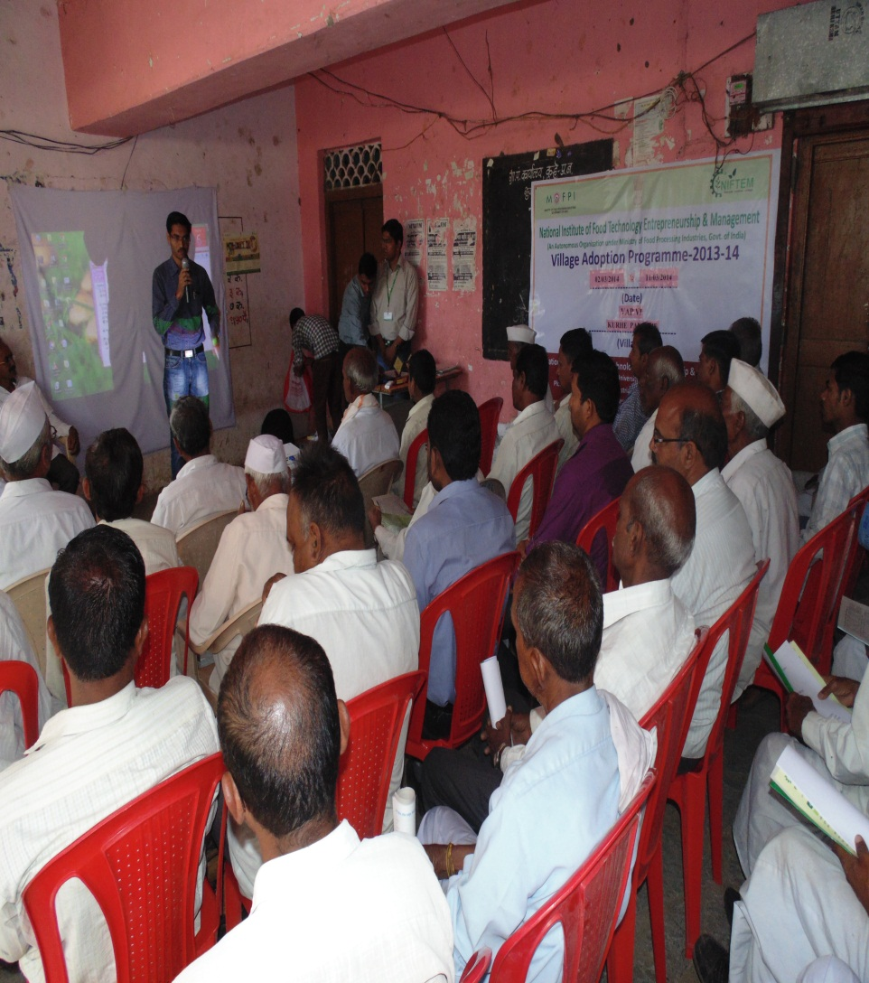
Demonstration of Bakery product preparation during a training session in the village in Madhya Pradesh | Interactive session of villagers with KVK representatives on Food processing opportunities in Kure, Bhusawal Maharashtra

- Entrepreneurship Development (Identification of Entrepreneurs)
- Phase 1
  - More than 125 entrepreneurs are potential ones who are associated with different teams and in processes of finalizing their ventures in agro food processing and few have already initiated the work.

- Phase II
  - VAP teams also identified about 50 prospective entrepreneurs in their respective village and adjoining areas who will be further given training to establish ventures in agro-food processing (Total about 1546). They will be imparted 1 week training programme and of those selected ones will be taken up for 1 month EDP programme in regional centers followed by 3 months of industrial training programme. During VAP 8, about 250 such entrepreneurs were trained in selected pilot locations by impartig1 week training programme.

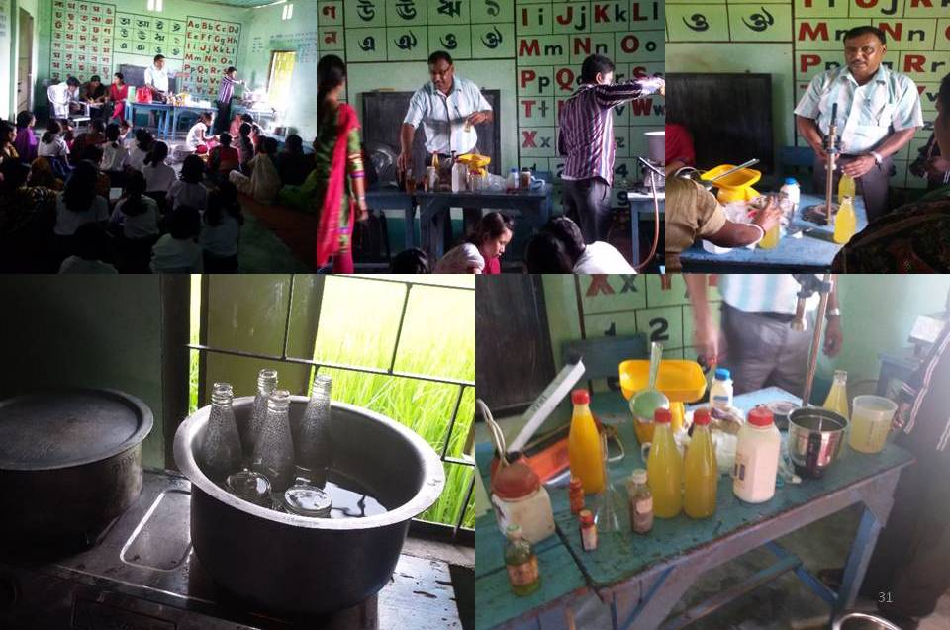 | 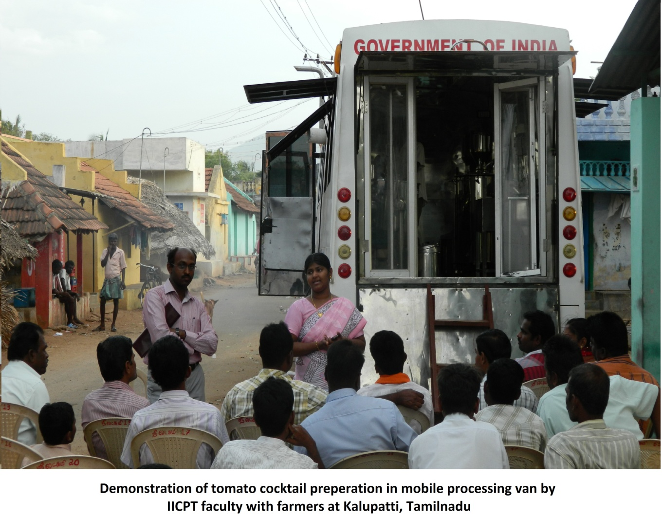
Fruit squash production and botteling demonstration in Uttar Shibakara village, West Bengal | Demonstration of Tomato cocktail preparation in mobile processing van arranged by Team NIFTEM , Kalupatti, Tamilnadu

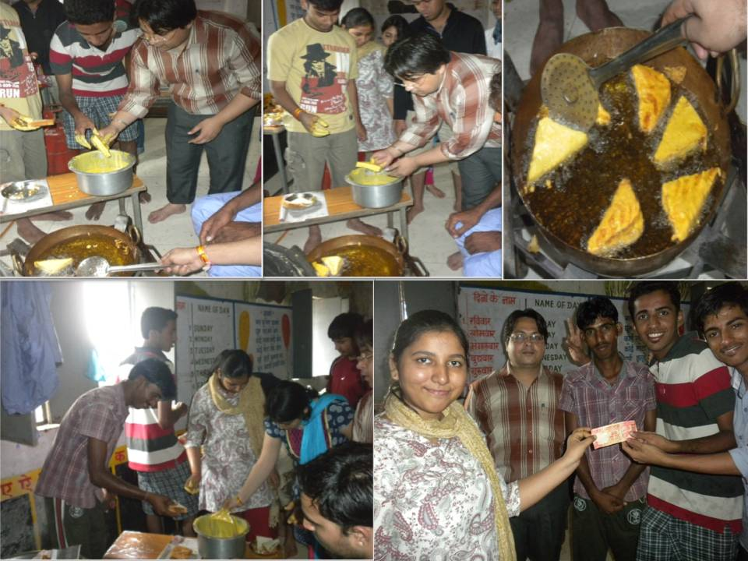 | 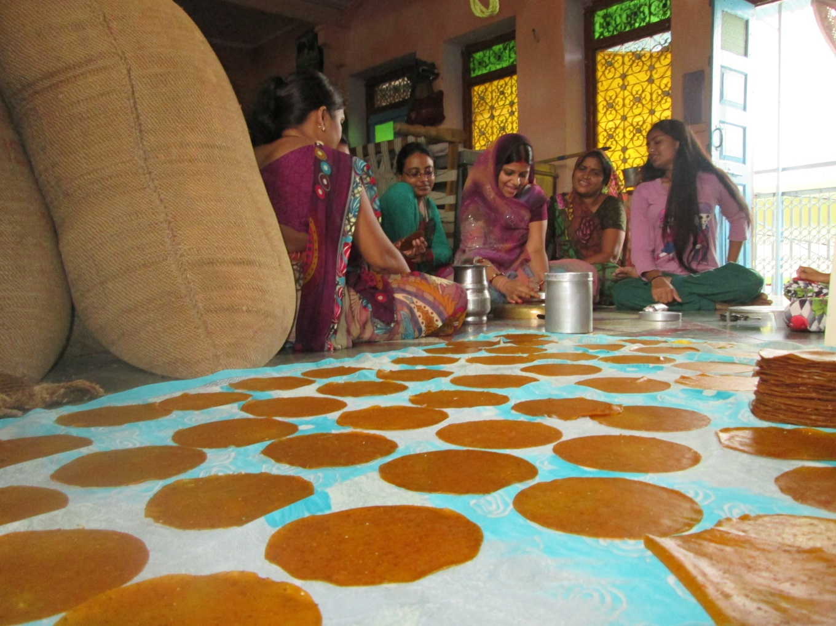
Members of team NIFTEM working closely with rural youth to support entrepreneurial venture of opening & running a canteen in village School (production-selling-estimated investment), Bagroda, Bhopal | Members of team NIFTEM working closely with rural women in the village on Papad Making Initiative, Jhalarpatan, Rajasthan

- Preparation of project reports
NIFTEM VAP Teams are continuously working very closely on different micro and medium level projects with selected potential entrepreneurs to guide and share the relevant information. The teams have shared with them customized project reports for initiating and supporting their ventures in domain of agro food processing and value addition.

- Product Development processes

Students along with their mentor have taken about 150 Product Development Training Programmes at village level in different villages and practically demonstrated preparations of jams, jellies, pickles, fruit based beverages like mango panna, products like banana chips, dried banana flakes, bakery products like biscuits, cakes, fried snacks like bread pakora, bread rolls etc and also share one to two page leaflets indicating the process flow charts and estimated expenses

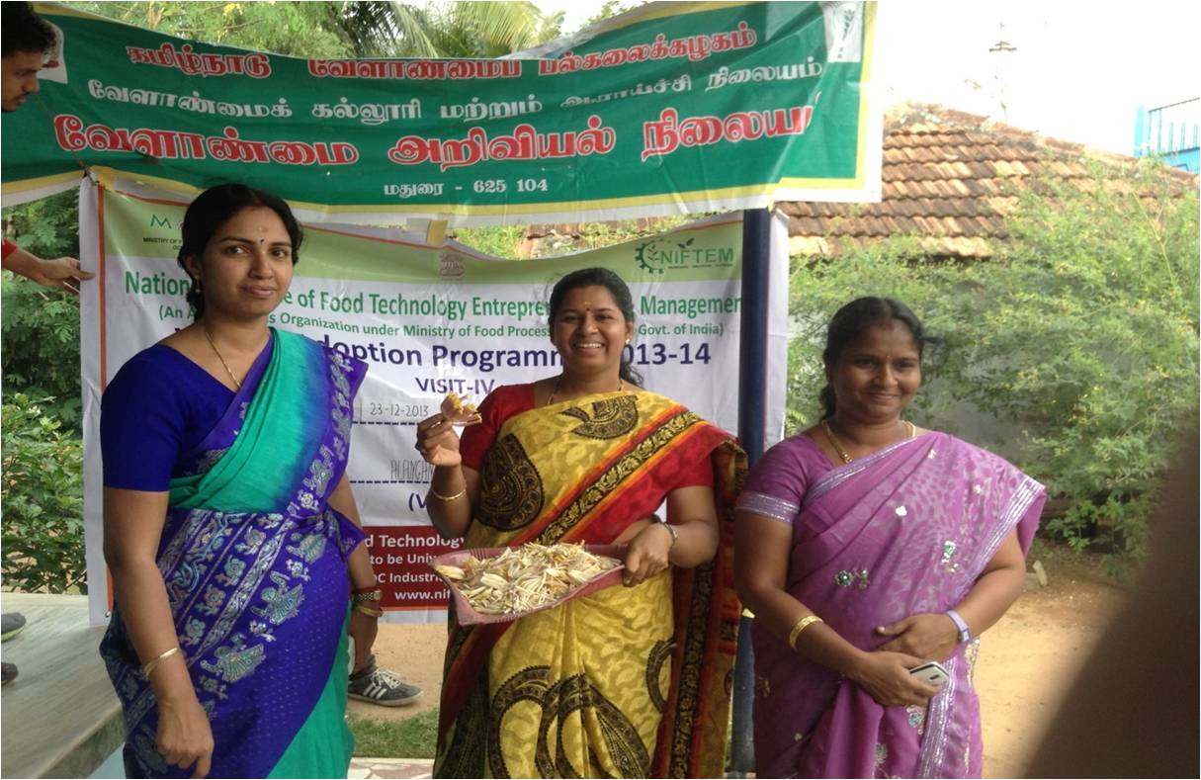 | 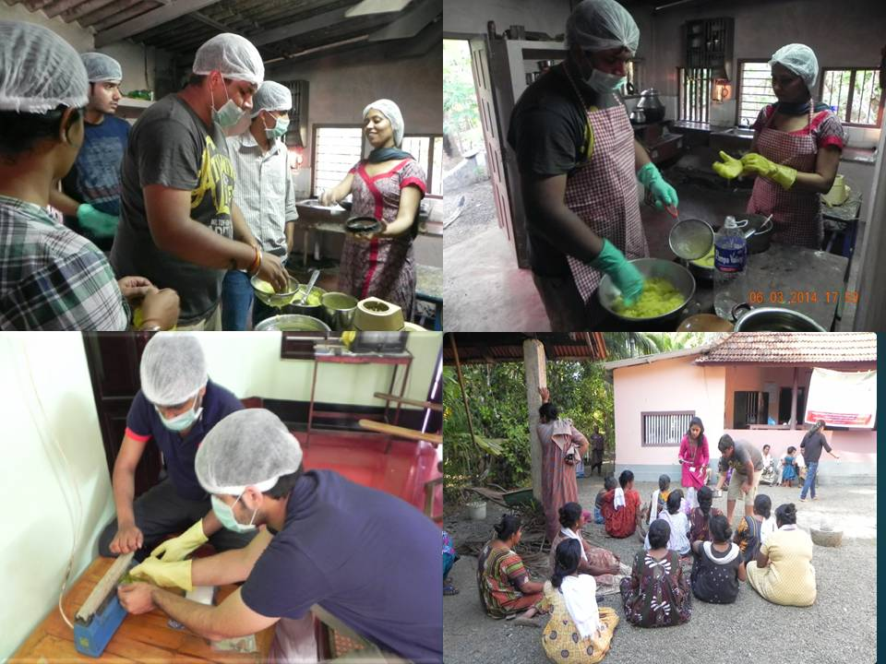
Training program on Banana flower pickle making by Members of Team NIFTEM in Alanganallur, Tamilnadu | Demonstration on making and packing of Mango products like Aam panna and pickle by Team NIFTEM in village Pulicunnoo, Kerala

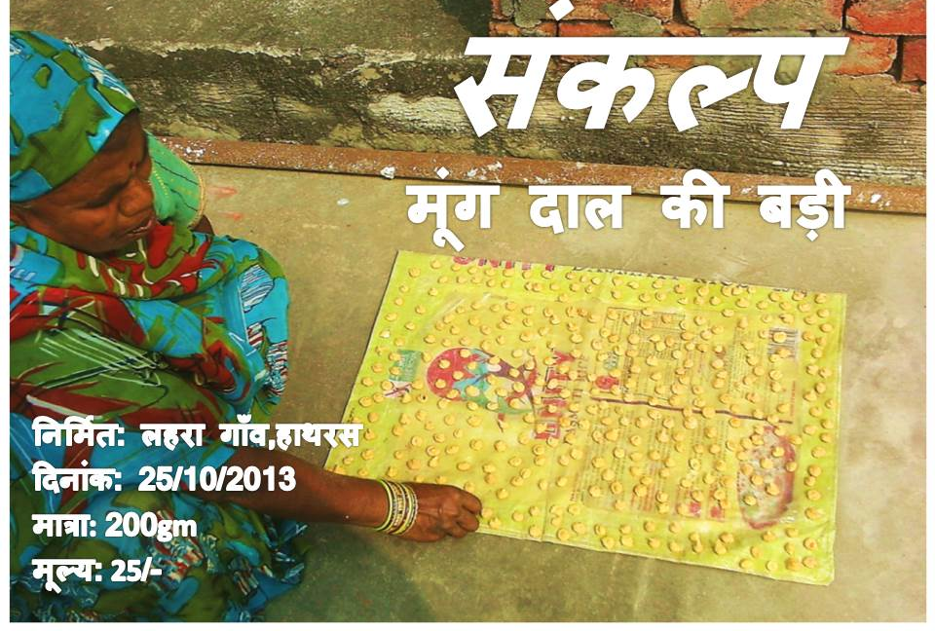

Products made at village level after creation of Women SHG by Team NIFTEM and promoted under brand name of “Sankalp”, Village Lahra, Hathrus, UP

- Developing Market Linkages

Team VAP in Different locations worked with various self help groups and supported to form backward and forward linkages for their product and process developments and promoting their products in the market. This organized effort lead to revival of about 115 exiting self help groups and creation of about 28 New Self help groups.

- Cataloguing of traditional knowledge
- Preparation booklets on traditional food recipes
  - Almost all the existing groups have completed the process of cataloguing the traditional recipes of their respective locations and has documented in form of small booklet. There are about 500 such recipes which are unique and with scientific intervention can be standardized for mass production and sold in domestic as well as export market.
- Preparation of booklets on traditional food preservation practices
  - Various groups have compiled information on traditionally existing Food Preservation Practice and documented them in form of booklets. About 200 such methods have been documented by various teams.

- Make in India initiative through VAP
  - As the efforts were directed to collect the traditional recipes as part of local heritage which could be further standardized and made popular for National and International market, NIFTEM is in process of finalizing few best recipes to initiate the research project on scientific interventions, quality management, protocol development and standardization for commercial production.
  - Apart from this various handouts, video shows, pamphlets, rallies were also carried out in villages to raise awareness among youth and prospective entrepreneurs.

- Infrastructure Development

VAP teams has networked with district administration and worked diligently for creation of tangible infrastructure like development of roads linking to main roads, access to potable water, repair of drains, creation of sanitation facilities by creating awareness about government schemes and subsidies on creating pukka toilets in houses, development of school building, plantation drives, addressing meal quality issues in mid day meals schemes of Anganwadi, etc. Amazingly the efforts yielded construction of more than 220 pukka toilets in the associated villages, about 27 vermi-composting units and about 38 initiatives were going on for renovation of roads, drains, school building, anganwadi infrastructure, installation of clean drinking water sources.
Efforts of Team NIFTEM under VAP leading to construction of Pukka Road in village Kalavacharla, Rajahmundry/East Godavari, Andhra Pradesh

- Social Issues addressed

Above 450 dedicated programmes addressing social issues on Girl child education, Female Foeticide, Child labour, Health care, Sanitation and Hygiene have been organized in adopted villages.

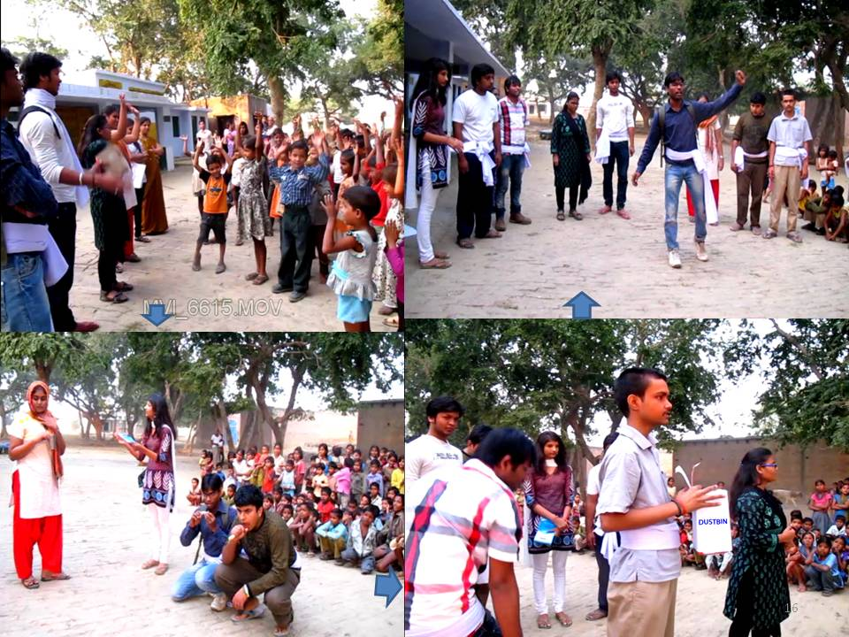

Nukkad Nakak organized by members of Team NIFTEM on raising awareness about avenues in food processing and importance of hygiene and sanitation in village in Uttar Pradesh

In a very unique initiative Team NIFTEM under its village adoption programme undertook an initiative to share and increase the knowledge of rural community targeting youth, women and children by opening of NIFTEM Gyan Kendra (Village library), either in common accessible panchayat office location or at village school. So far as about 24 such libraries have been created and since their inception Team NIFTEM has enriched the library resources by collecting and contributing about 569+ books which includes books on management, subject textbooks, current affairs, general knowledge, preparation for competitive books, homemaking, food processing, agriculture management, good agricultural practices, etc.

- Swachh Bharat Abhiyan

In recently completed VAP 8, Swaach Bharat Abhiyan was taken up vey rigorously and about 35 dedicated programmes were organized to raise awareness about this programme leading to cleanliness drive in school, in respective village and nearby locations. Teams also created Core teams in Village schools to sustain the campaign.

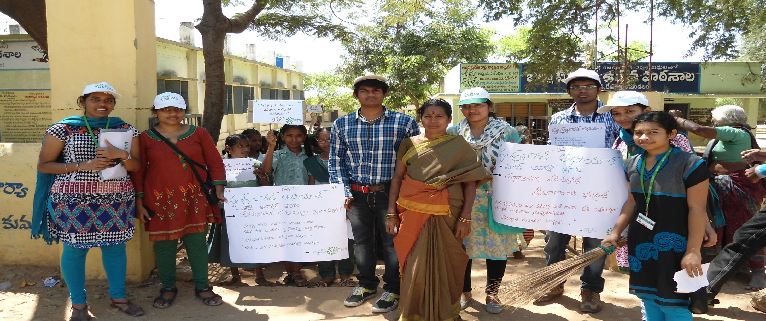 | 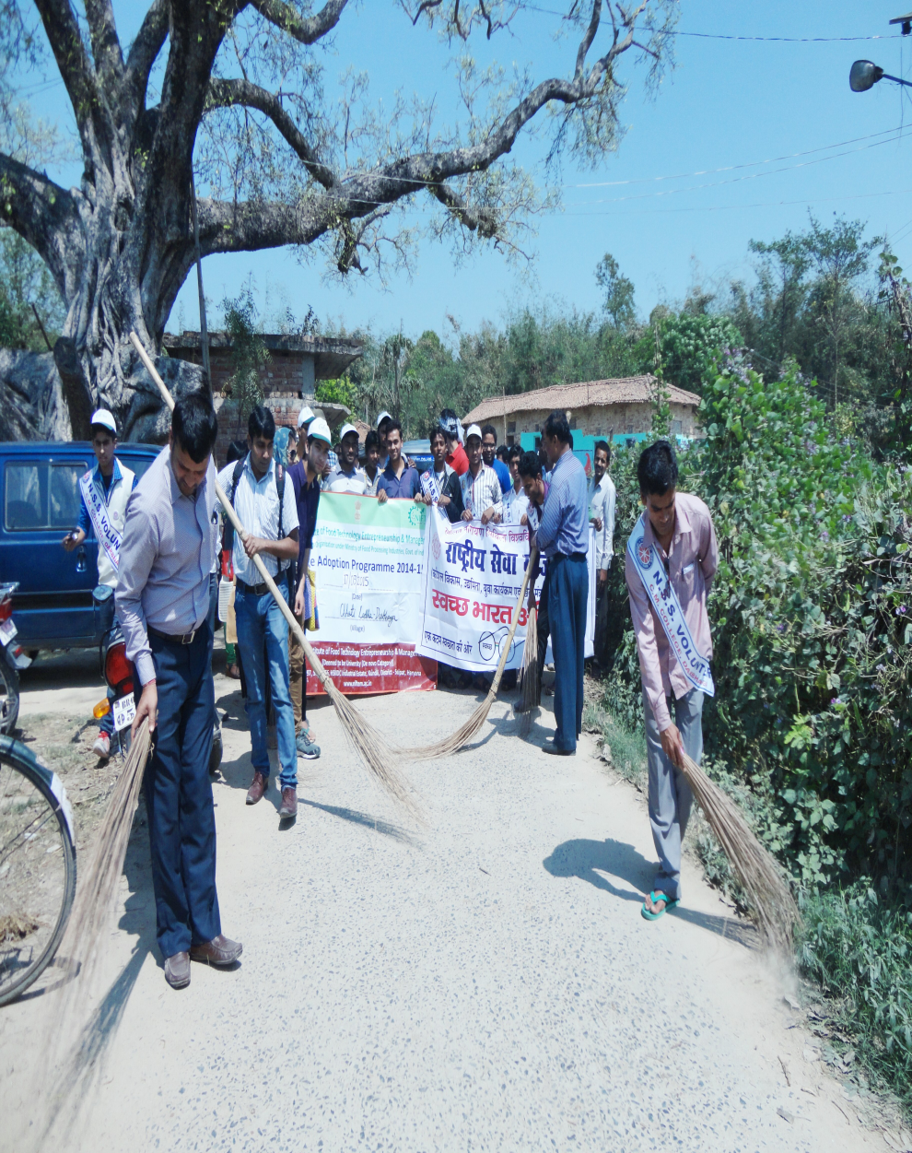
Swachh Bharat Abhiyan undertaken at a Village Karkambadi, Chittor, AP | Swachh Bharat Abhiyan imitative in Chotti Ladha, Bihar

- Initiatives on promotion of Renewable energy utilization

VAP teams laid due emphasis in promotion of renewable sources of energy like Solar lighting, solar cells and contacted energy department of each state to send representative in the village and educate farmers about using the solar lights. Sarpanchs and Panchayats were made aware about subsidies available for them to take solar lightening project for the village.

Success has been achieved in installing Solar Panels for heating water and solar lamps in houses as well as Solar Street lights. The effort yielded about 100 dedicated lectures on promotion on renewable energy about 99 awareness campaigns installation of about 110 solar street lights/ solar lamps in different locations under VAP. Few biogas plants (25 in numbers) were also established in different locations.

Awareness raising efforts of Team NIFTEM on renewable sources of energy leading to installation of Solar Lights in the Village Jhalarpatan, Junakheda, Rajasthan

Interaction with representatives of MP Uoorja Vikas Nigam for promotion of renewable sources of energy leading to installation of Solar panels in the Village Bagroda, Bhopal, MP

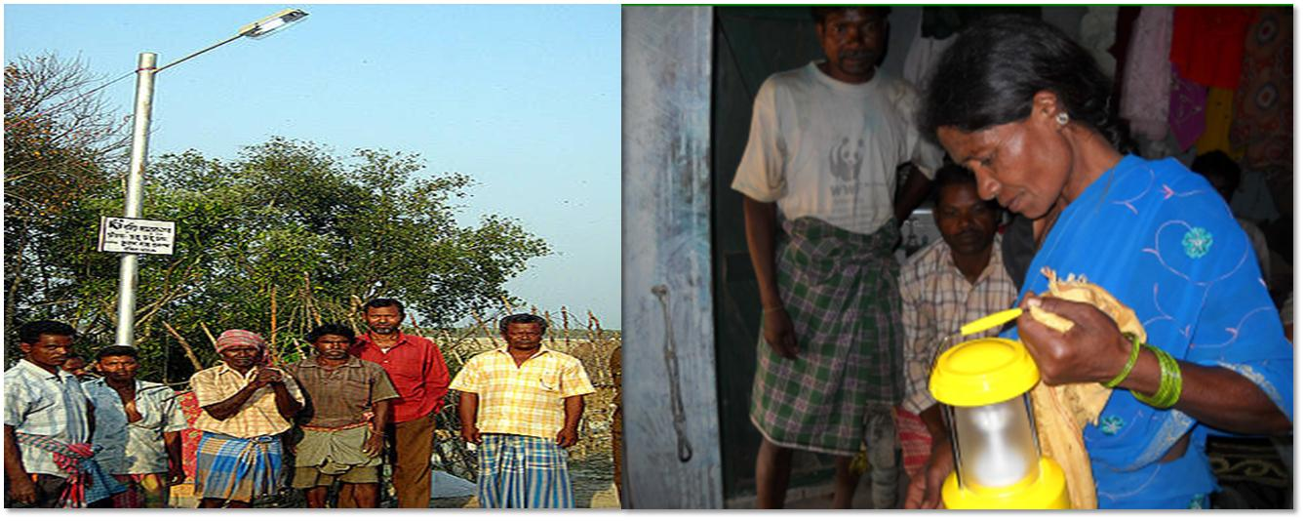

Installation of Solar lights in Hariharpur, Bihar
The consolidate activities under VAP are presented in tabular form in Annexure II

Future Programmes
- Now we are in the process of planning the launching of a programme for skilling the entrepreneurs by starting five days training programme in the village location itself followed by a follow up advanced training of four weeks on entrepreneurship development to the selected entrepreneurs so as to take them to the logical end of establishing micro enterprise. This programme would be followed by a six months “Hand Holding Phase” so that the trained entrepreneur is assisted in all the activities viz. preparing DPR, taking loan from the bank, procurement of equipments and machinery, marketing tie ups, etc.

- Our efforts will be directed towards establishing Primary Processing cum Pre-Cooling centre in the village, which could become the hub for hands-on training of farmers and rural youth in food processing and also provide limited CA storage to the farmers for their perishable fruits and vegetables, etc. Attempts are being made to develop a Hybrid Energy System (Solar+ Biomass+ Grid Electricity) to run theses primary processing centre.

Annexure I
Selected Village Locations under NIFTEM’s Village adoption programme
(State-wise presence as on March 2015)

S.No. | Name of the Village | Block and Sub District/ District | STATE
 | Kalavacharla | Rajahmundry/East Godavari | ANDHRA PRADESH
 | Karakambadi | Renigunta/ Chittoor | ANDHRA PRADESH
 | Harihapur | Hajipur, Vaishali | BIHAR
 | Chhoti Ladha | Keoti/Darbhanga | BIHAR
 | Khairimal | Chakia/ East Champaran | BIHAR
 | Koyli | Vadodara | GUJARAT
 | Gangwa | Hisar | HARYANA
 | Rawalwaas Kala | Hisar | HARYANA
 | Nauni | Solan | HIMACHAL PRADESH
 | Tunna | Mandi | HIMACHAL PRADESH
 | Hocher | Kanke / Ranchi | JHARKHAND
 | Mangur and Yalgud | Belgaum and Kolhapur | KARNATAKA and MAHARASHTRA
 | Pulincunnu | Veliyanad/ Alappuzha | KERALA
 | Bagroda | Phanda/ Bhopal | MADHYA PRADESH
 | Simariya | Seoni | MADHYA PRADESH
 | Kure | Bhusaval/Jalgaon | MAHARASHTRA
 | Pimpri Gawli | Ahamednagar | MAHARASHTRA
 | Lathor | Kaprakhole/ Balangir | ODISHA
 | Dhansimulia | Balasore | ODISHA
 | Vairowal | Tarn Taran | PUNJAB
 | Mansakalan | Bathinda | PUNJAB
 | Behniwal | Sardulgarh | PUNJAB
 | Tarmala | Lambi / Muktsar | PUNJAB
 | Aloda | Sikar | RAJASTHAN
 | Junakheda | Jhalarapatan/ Jhalawar | RAJASTHAN
 | Samlik Marchak (Nandok ) | East Sikkim | SIKKIM
 | Alanganallur | Alanganallur/Madurai | TAMILNADU
 | Kallupattai | Rajakapattai/Dindigul | TAMILNADU
 | Parseda/Amauli | Fatehpur | UTTAR PRADESH
 | Naglamohan | Mathura | UTTAR PRADESH
 | Arjunpur | Bakshi Ka Talab/ Lucknow | UTTAR PRADESH
 | Bichpuri | Bichpuri/ Agra | UTTAR PRADESH
 | Dhanpau and Lakhwad | Dehradun | UTTARAKHAND
 | Dakshin Kalrayar Kuthi | Cooch Behar/ Cooch Behar-2 | WEST BENGAL
 | Dakshin Arjunda and Chalkradhabon | Gram Panchayat -Chaitanyapur-1/ Block Panskura-1, Midnapore (E) | WEST BENGAL
 | Kamlapur (Nimpith) | South 24 Parganas district | WEST BENGAL

Annexure -II

Salient Achievements in VAP (consolidated in Numbers)
Sr No | Activity | In Numbers
 | Food Processing promotional Initiatives
 | Number of lectures arranged on:
 | - Promoting Postharvest management & Food Processing / Value addition | 208
 | - Promotion of renewable energy | 112
 | - Entrepreneurship development | 134
 | - Sanitation and hygiene | 159
 | - Girl child education/ education | 126
 | - Female feoticide | 35
 | - Alcoholism | 51
 | - Other GAP, Government schemes, Banking and finances, Subsidies, Dairy and poultry farming, Organic farming, Alcoholism, Social issues, etc | 87
 | TOTAL | 912
Number of training programmes on product /process development
organized/conducted in village (Jam/pickle/ chutney/ beverage/biscuit/cake/ paneer/ Khoa/toffee etc.)
 | · Duration 1 day | 118
 | · Duration 2 days | 29
 | · Duration 5days | 9
 | TOTAL | 156
 | Number of entrepreneurs/potential indentified in Phase I  Team NIFTEM is working very closely with these entrepreneurs since VAP I in the respective villages and guiding then through various states of their venture establishment and promotion in core area of postharvest management, organic farming and agro-food processing. | 125
 | Potential Entrepreneurs selected for training in Phase-II  VAP teams also identified about 50 prospective entrepreneurs in their village and adjoining areas who will be further given training to establish ventures in agro-food processing | 1546
 | Detail project reports on ventures in food processing sector prepared and shared with budding entrepreneurs in the village | 138
 | Market surveys conducted | 113
 | Opening of NIFTEM Gyan Kendra (Village library) | 24
 | Approximate Number of Books contributed to Gyan Kendra (since initiated) | 569
 | Awareness campaigns
 | - Jan chetna yatra | 91
 | - On postharvest management | 153
 | - On promotion of renewable energy | 99
 | - Sanitation and hygiene | 129
 | - Social issues | 128
 | TOTAL | 600
 | Number of medical camps organized | 45
 | Pamphlets created
 | - On food processing/Postharvest management Value addition/GAP (English/Hindi) | 115
 | - On food processing/Postharvest management/Value addition (in regional language) | 101
 | - On Social issues (alcoholism/smoking/etc) | 103
 | Video shows
 | - PHM/GAP/Food Processing | 228
 | - Sanitation and hygiene | 114
 | - Renewable energy | 65
 | TOTAL | 407
 | Number of Visits for farmers to industry and institutions | 72
 | Collection and documentation of traditional recipes | 494
 | Collection and documentation of Traditional methods of storage (in numbers) | 217
 | Documentary prepared during village adoption programmes (on various topics like Govt. Schemes, opportunities on food processing, sanitation hygiene, before and after comparisons, etc. ) | 35
 | Plantation drive | 65
 | Nukkad Natak/Skit | 39
 | Total Number of the members in the Core groups created by respective VAP teams in their village | 468
 | Visible Impact
 | - Number of success stories identified | 73
 | - Venture/s initiated by identified entrepreneur, if any | 78
 | - Formation of New SHG | 28
 | - Reviving/guiding existing SHG | 116
 | - Number of solar lamps/ solar street lights installed in different villages | 113
 | - Number of Toilets construction in different villages | 222
 | - Construction of roads/pathway/drains/ renovation of school buildings and angan wadi infrastructure/ installation of clean drinking sources etc | 38
 | - Installation of biogas unit | 25
 | - Construction of vermin-composting unit | 27

